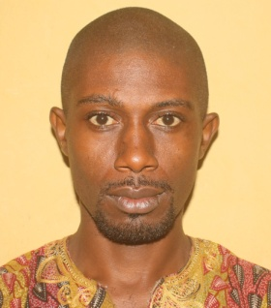
Nnamani Vitus Sunday
Mr.
Department of Public Administration and Local Government
Faculty of the Social Sciences
sunday.nnamani@unn.edu.ng
08030938593
Lecturer 11
I am from Ekperemere Likke Iheaka, under Igbo-Eze South L.G.A of Enugu State, Nigeria. My religion is Christianity. Date of birth: 17th April, 1981. I speak fluently Igbo and English Language. Finally, I am married with 2 children (a girl and a boy).

I specialize in Human Resource Management

EDUCATION: M.Sc in Public Administration
(Human Resources Management) UNN - - - - - 2016
B.Sc Public Administration and Local Government UNN - - 2010
Professional Diploma in Education ABU Zaria - - - - 2011
Certificate of Proficiency in Computer Literacy Afrihub UNN - 2011
NYSC Discharge Certificate - - - - - - 2011
Certificate of Training (Graduate Internship Scheme)
Federal Ministry of Finance - - - - - - 2015

Responsibilities
Teaching and invigilation, marking of examination scripts, Supervision of Diploma and B.Sc projects, participating in other departmental activities like member environmental committee, member timetable committee, attendance to departmental board meetings and available for the Head of department to assign any other responsibility to me.

