UNIVERSITY OF NIGERIA, NSUKKA
PUBLIC ADMINISTRATION AND LOCAL GOVERNMENT

MEMORANDUM
To: All Staff  Our Ref: | From: Head of Department  Date: April 18, 2018

SUBJECT
RE: Updating of Staff Profile on UNN Website
All the new staff, both academics and non-academics, from2016-2018 are required to provide the following information to enable us create their profile in the University Website.
Picture 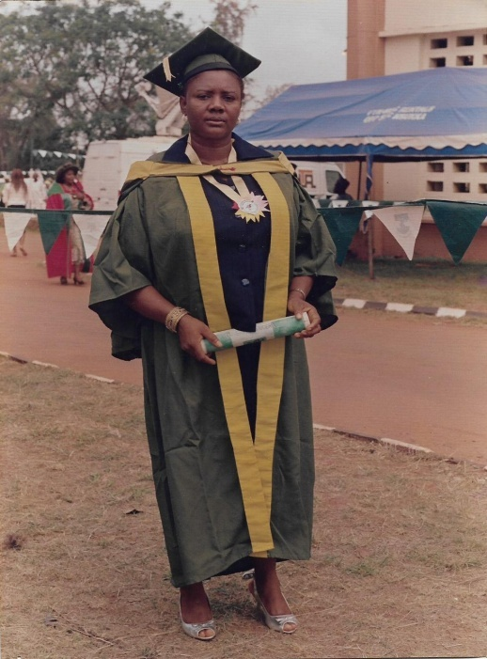
Name: Nwodo Virginia Ijeoma
Maiden Name:
Title: Mrs.
Department: Public Administration and Local Government
Faculty: Social Sciences
E-mail: ijeoma.nwodo@unn.edu.ng
Phone No. 07061014270
Designation: Higher Technical Officer II
Brief Biography: My name is Nwodo Virginia Ijeoma. A native of Ukehe in Igbo-Etiti L.G.A of Enugu State. I am married. I am a staff of Public Administration and Local Government in University of Nigeria, Nsukka.
Area of Specialization: Public Administration and Local Govt.-Human Resource Management
Qualification: F.S.L.C, WAEC, NCE, B.Sc, M.Sc.
Responsibilities: * Filing and keeping Sandwich results
* Keeping inventory of office equipment
* Carrying out any instruction or job as directed by my HOD

Signed:
Prof. C. Ofuebe
HOD

