MR OLUWOLE ISRAEL OLUWASANMI
NCE, B.Sc/Ed, M.Sc, Ph.D in View

Department: Public Administration and Local Government
Faculty: Social Sciences
Designation:
Email Address: israel.oluwole@unn.edu.ng
Phone: 08038256337, 08071115801
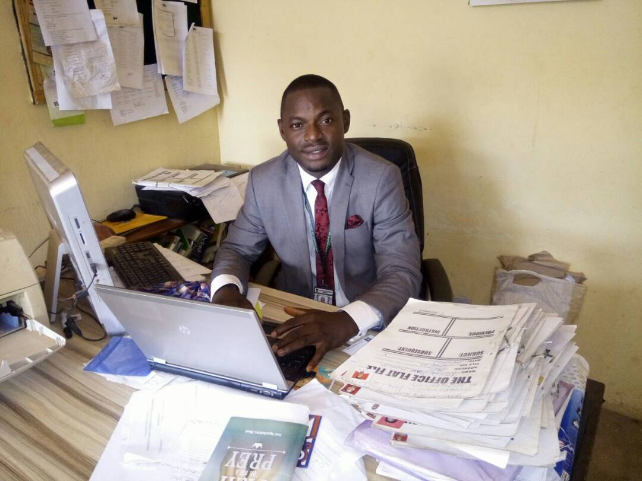
Biography:
Mr. Oluwole Israel Oluwasanmi was born on August 25, 1985 into the family of late Pastor Samuel Oluwasegun Oluwole in Ogotun Ekiti, Ekiti South West Local Government, Ilawe Ekiti, Ekiti State, Nigeria.
Mr. Oluwole Israel Oluwasanmi had his primary school education in Owu Ikija Primary School, Owu Ikija, Ogun State in 1997. He obtained his West African Senior School Certificate Examination from Ekiti Baptist High School, Igede Ekiti, Ekiti State in 2004 and the Nigeria Certificate in Education (NCE) in History and Political Science from Ekiti State College of Education, Ikere Ekiti in 2007. He attended University of Nigeria, Nsukka and obtained a Bachelor of Science Degree in Education and Political Science in 2012 with Second Class Honours (Upper Division). He also bagged his Master’s of Science Degree in the same University, department of Political Science (Conflict, Peace and Strategic Studies) in 2016. Presently, his undergoing his Doctoral degree in Political Science with area of interest in Conflict, Peace & Strategic Studies, University of Nigeria, Nsukka.
Currently, he is a lecturer in the Department of Public Administration and Local Government, University of Nigeria, Nsukka.
Mr. Oluwole Israel Oluwasanmi joined the Department of Public Administration and Local Government in 2016.
He is a devoted Christian, lives in Nsukka, Enugu State.
His hobbies include among others Research, Teaching, Networking, Travelling, Studying and Sport.

