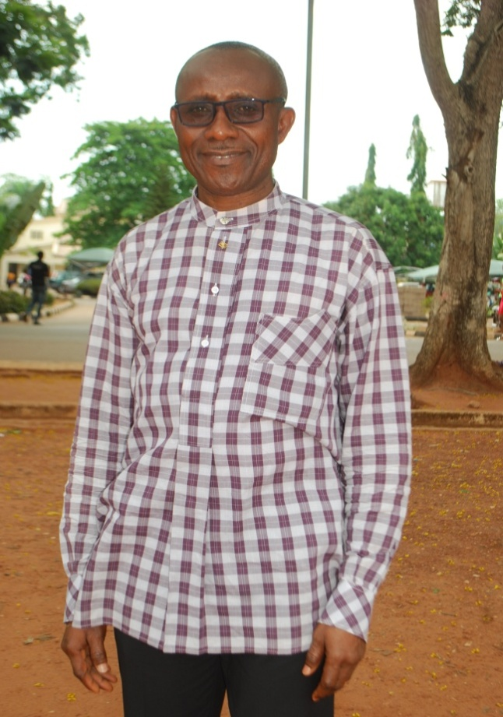
STAFF PROFILE

NAME: Nworisa Uzoma Geoffrey
TITLE: Mr.
DEPARTMENT: Public Administration and Local Government
FACULTY: Social Sciences
EMAIL: uzoma.nworisa@unn.edu.ng
PHONE NO: 07015479021
DESIGNATION: Graduate Assistant.

BRIEF BIOGRAPHY: A native of Ndimbara-Amaegbu in Nkwerre, Nkwerre Local Government Area of Imo State. Had primary education at Central School Nkwerre, and later Central School Amaokpara, all in Nkwerre Local Government Area. After post-primary education, was admitted into the department of Public Administration and Local Government, University of Nigeria, Nsukka in 2011 where I obtained a B.Sc. Degree with Second Class Upper Division in 2015. Having been awarded the Best Graduating Student of The Department for the year 2015, I enrolled for the Post-Graduate Programme of The University in 2016 and was employed as a Graduate Assistant in The Department of Public Administration and Local Government in 2017.

AREA OF SPECIALIZATION: International Administration
QUALIFICATION: B.Sc. Public Administration, M.Sc. in view.
RESPONSIBILITIES: Research Assistant, Any other assignment from the Head of the Department.
PUBLICATIONS: None

