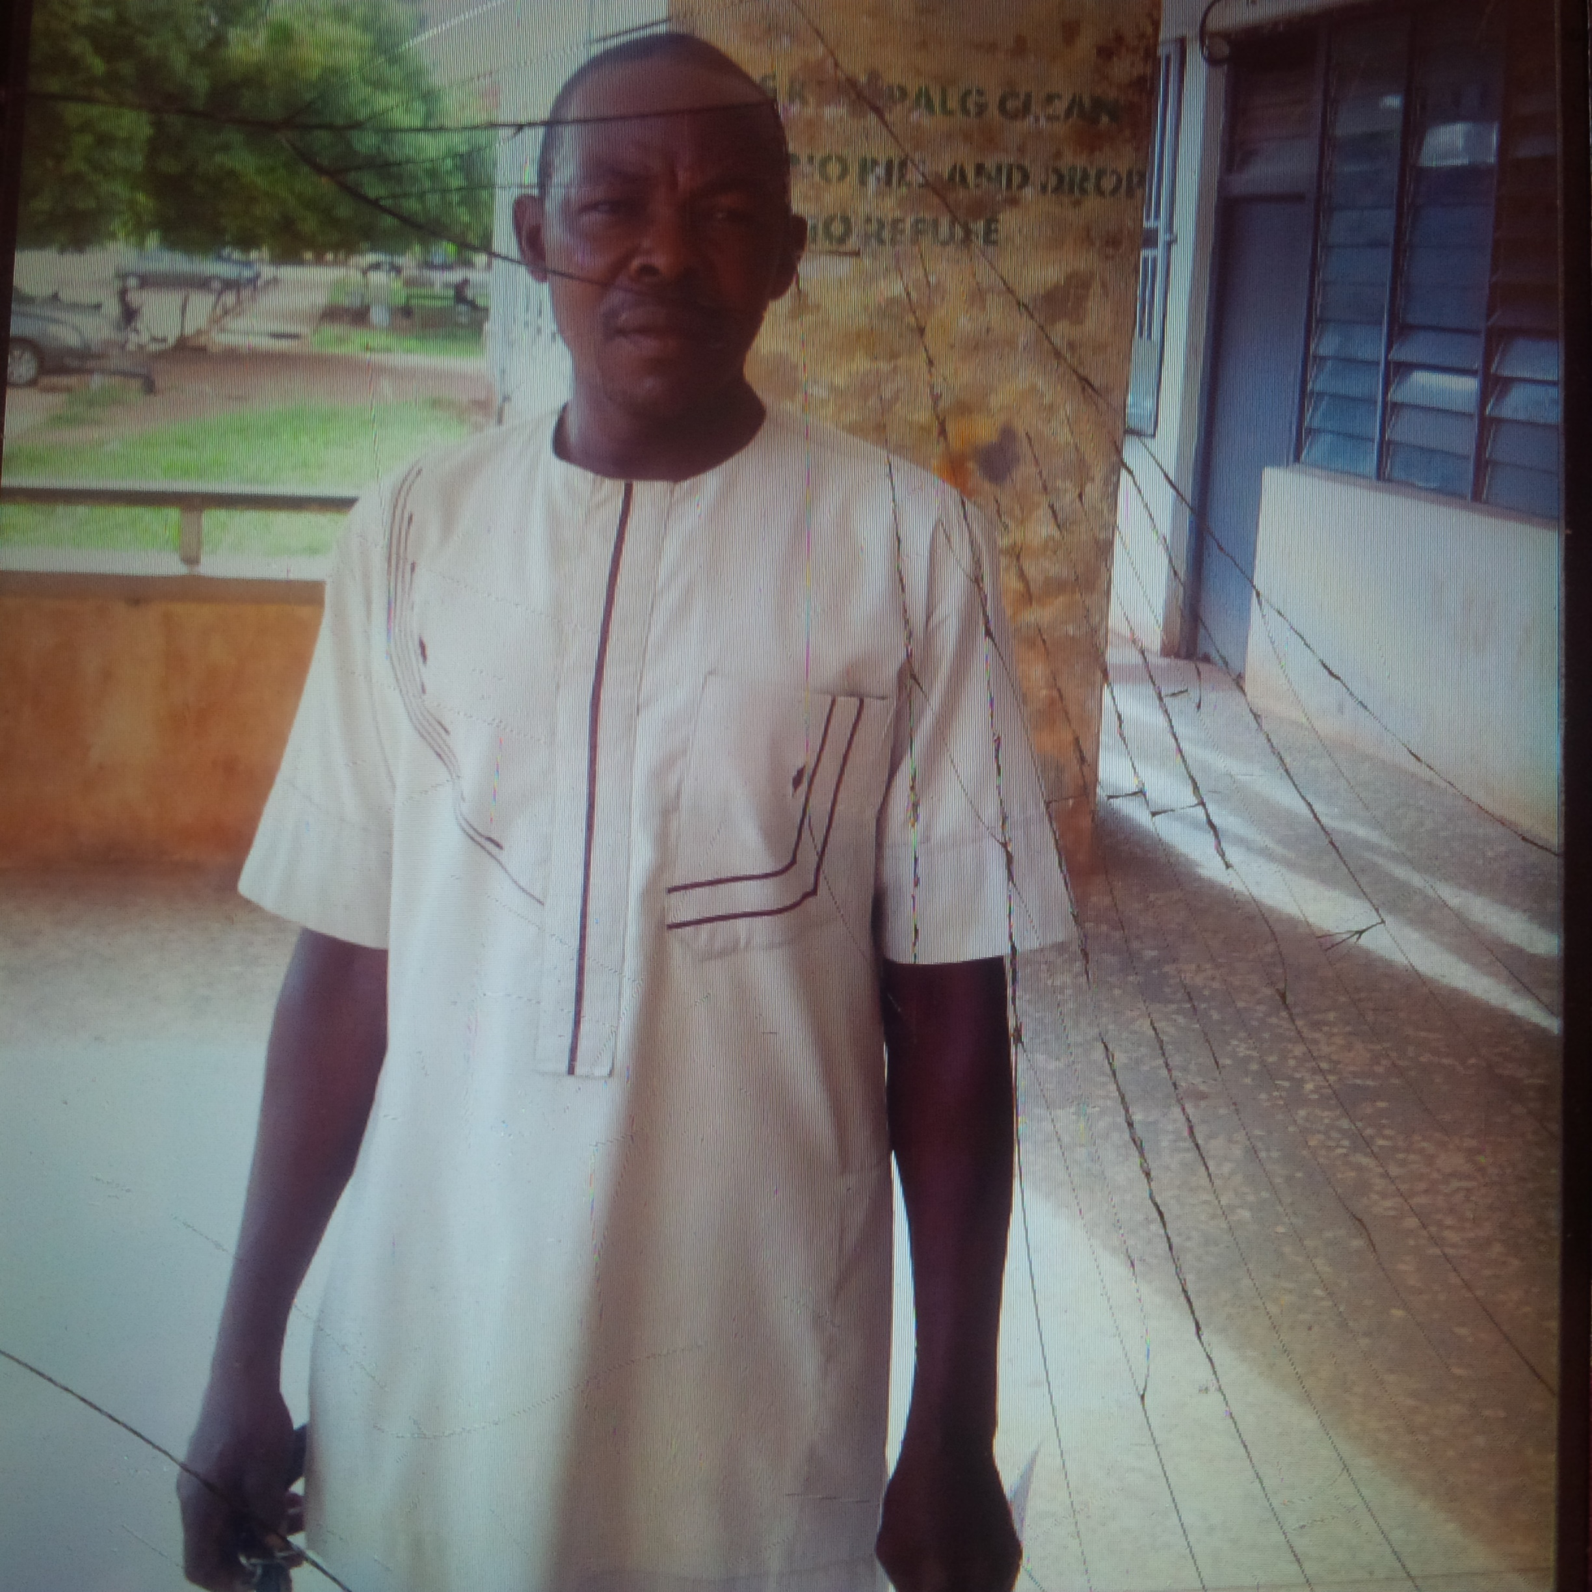
Name: Eze Samuel Nnabuike
Title: Mr
Department: Public Administration and Local Government
Faculty: The Social Sciences
Email: nnabuike.eze@unn.edu.ng
Phone No: 08064623748
Designation: Technical Officer
Brief Biography: I Eze Samuel was born into the family of Ogbuefi Eze of Abia in Udi Local Government of Enugu State on the 18th of September, 1963. I am married with two children. I obtained OND in Public Administration from the University of Nigeria, Nsukka in 2005 and presently working in the Department of Public Administration and Local Government.
Area of Specialization: Public Administration.
Qualification: Diploma.
Responsibility: creating/ registration of newly admitted PG students for PGD, MSc, MPA and PhD, arrangement of files for PGD, MSC, MPA and PhD students. I also assist in circulation of PhD, MSC defence/Seminar.

